Perceptron is single neuron i.e if we use sigmoid function then it gives o/p like LR and if Activation function is simple perceptron thresholding function we get perceptron .

some problems require connected neurons of network.

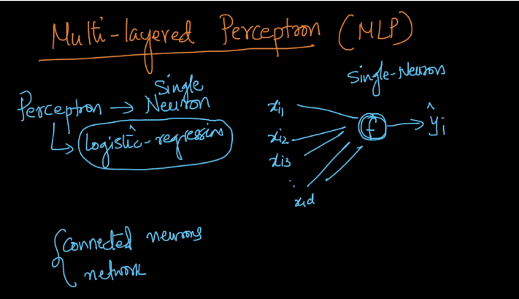

Below fig. shows multi-layer perceptron in this first layer is input layer and last layer which gives output is output layer, and all the layers b/w input and output layer is hidden layers.

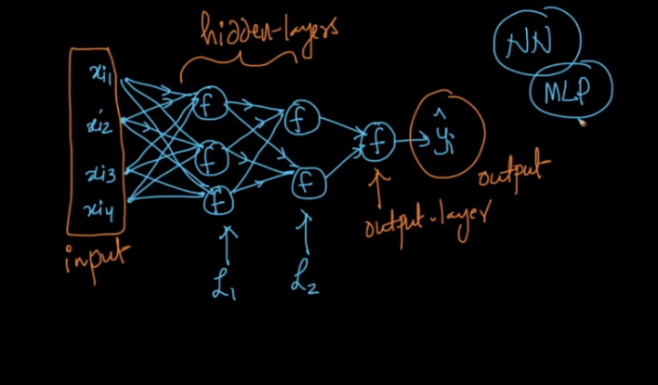

Why there is need for Multi layer perceptron

1. Biological inspiration : in brains there are many neurons and all are connected to each other this inspire us to create multi layer neural network to provide intelligence artificially to computers

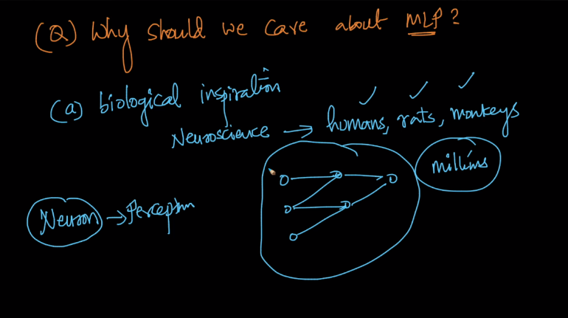

b) Mathematical :

lets take regression problem to show it, there are input values we have to find out function which gives us predicted output

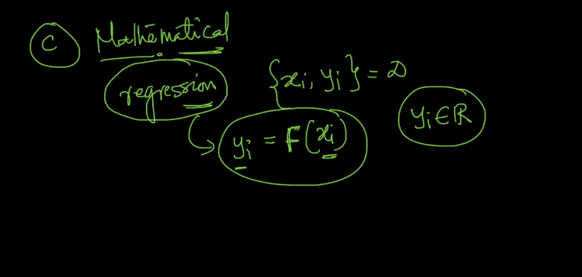

Below fig. shows graph of x vs y and we have values of x and y now how can we come up with function which gives us correct output.

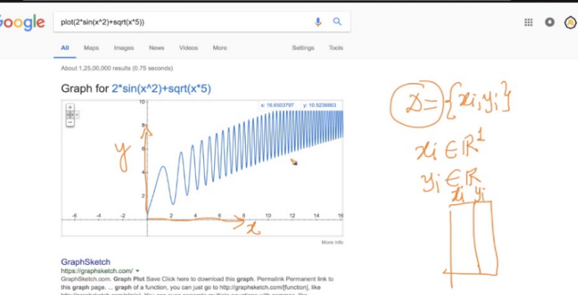

First approach we can take xi = yi in this way we got output as a line as shown in graph but this outputs lots of errors.

Similarly we can solve it using regression problem but by this also we got many errors because we got line in regression . now as we can’t solve this by above approaches therefore we need some function to solve it.

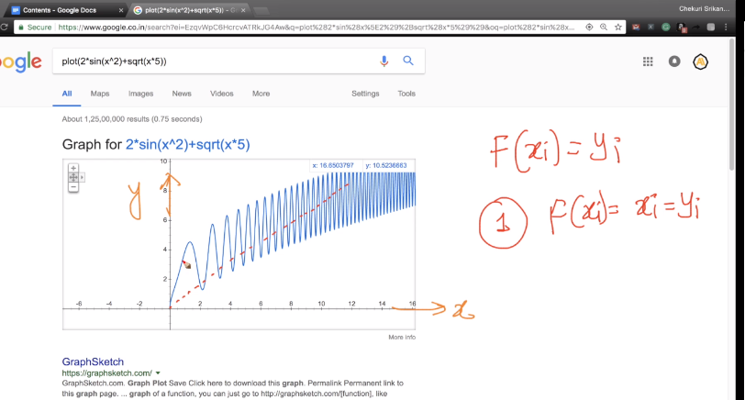

Function we want which gives correct o/p is shown below

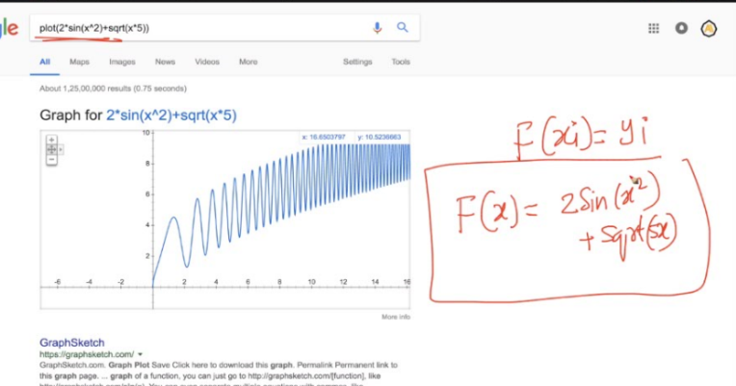

Now we can solve this by multi layer neural network where we provide functions in each neuron which is shown below,

As we need 5 below functions to solve this problem therefore we gives this function in neuron and provides input to this neuron which have function and got output.

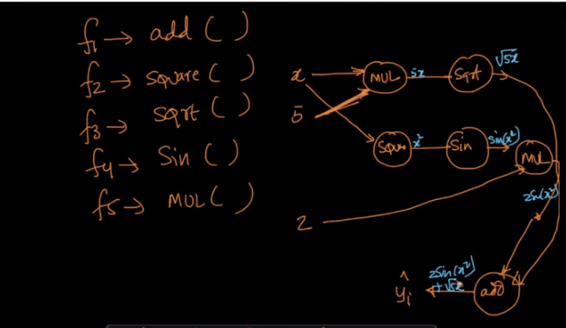

Below image shows about input, hidden and output layers

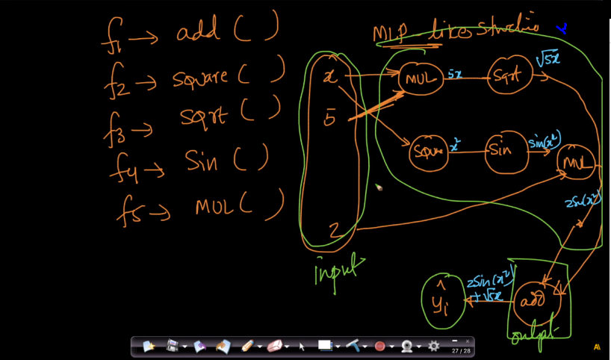

Therefore by above image we got by using multi-layered structure we can come up with complex mathematics formulae to solve complex problems

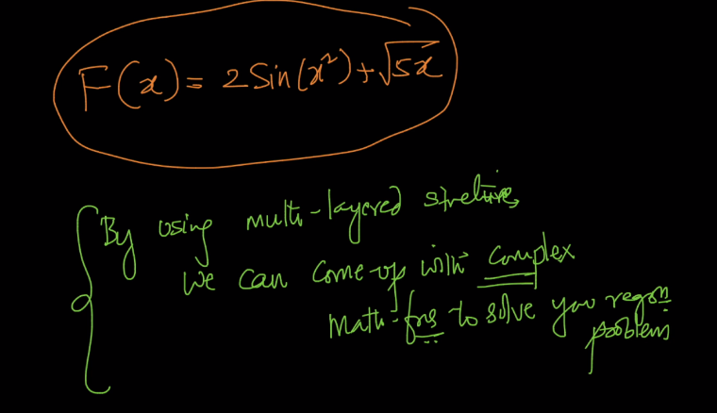

ML provides enormous power to solve complex problems

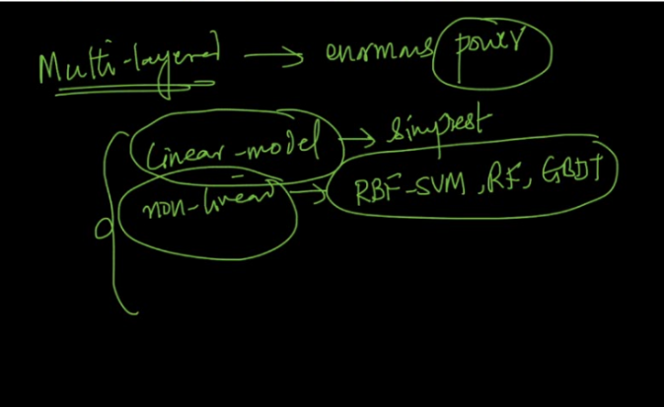

Multi layer perceptron is a graphical way of representing fog i.e f(g(x)) and gof i.e g(f(x)

Therefore as shown below 2sinx2 represented as f5(2, f4(f2(x))) and root(5)x as f3(f5(x,5))

And final F(x) as f1(f5(2,f4(f2(x))), f3(f5(x,5))

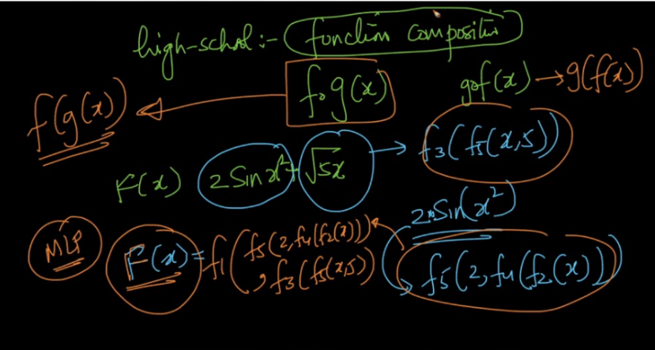

Multi layer structures are very powerful models but they have problem is that it can overfit very easily therefore in neural networks our main task is to overcome overfitness.

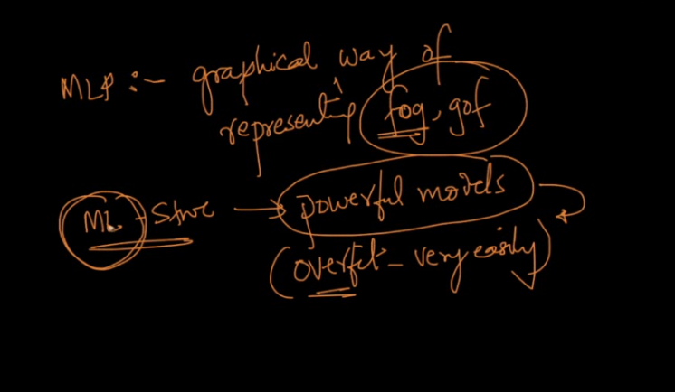

Comments :

<https://www.quora.com/Whats-the-reason-motivation-behind-using-a-sigmoid-logistic-activation-function-multiple-times-instead-of-different-activation-functions-one-at-a-time-in-a-neural-network-of-machine-learning>



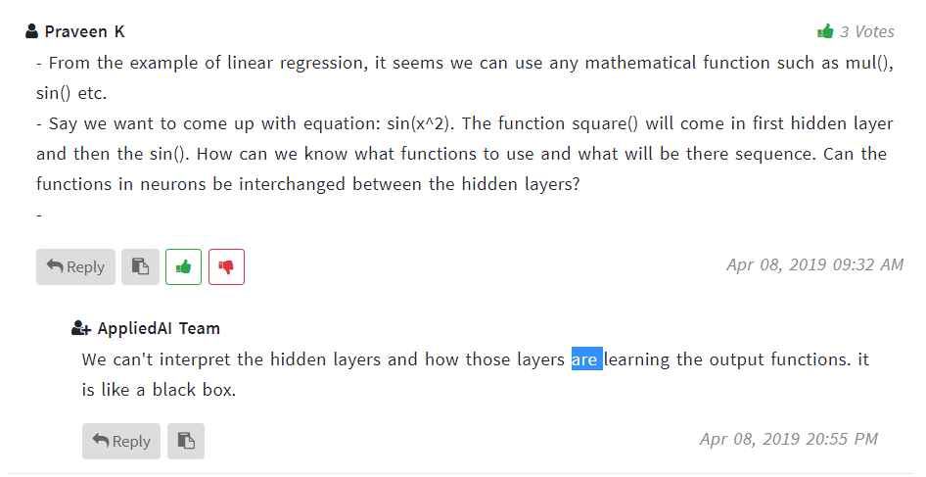

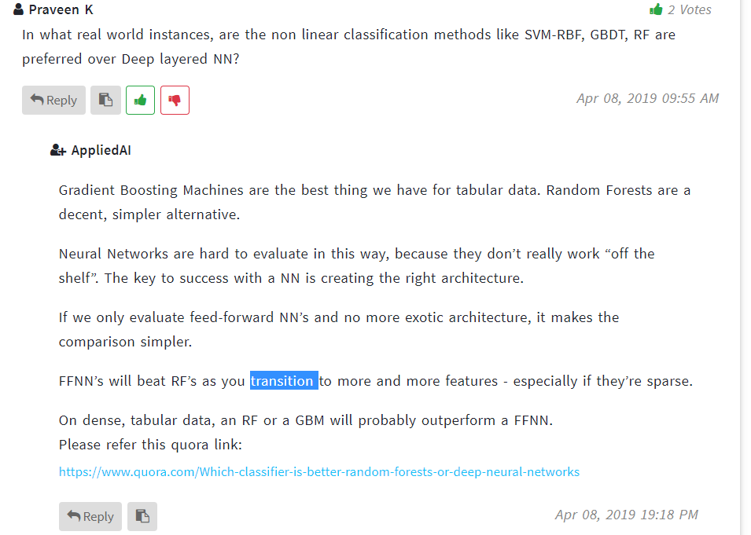

https://www.quora.com/Which-classifier-is-better-random-forests-or-deep-neural-networks